1-REFLECTED XSS:
It is a type of XSS -Client vulnerability in which a payload or a malicious code is injected in a web application and by inserting the payload the users data becomes vulnerable to the attacker.
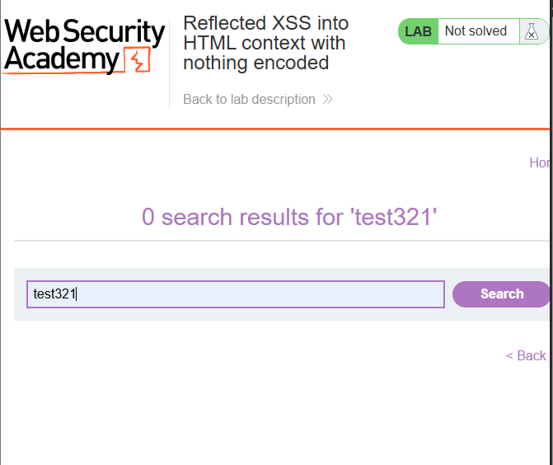

From the picture above you can see that the user input is reflected in its output and therefore the application the user entered is vulnerable to XSS reflected vulnerability.

2 STORED XSS:
It is a type of vulnerability in which the attacker inserts a payload in for example a web page where customers give their account of the product they consumed but instead of the attacker writing a comment in the comment section the attacker inserts the below code.
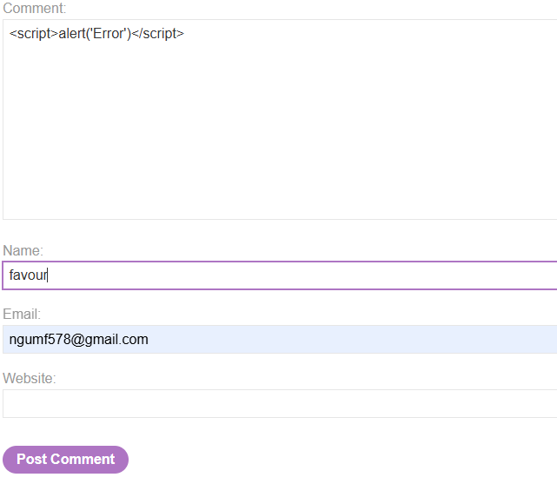
- DOM-BASED XSS:
This is a type of XSS vulnerability in which the attacker inserts a payload in the URL parameter by replacing the request with a malicious code for example <script>alert(‘20’)</script> and calling alert function.

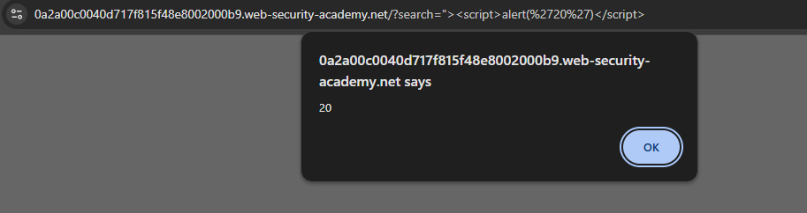
Figure 1
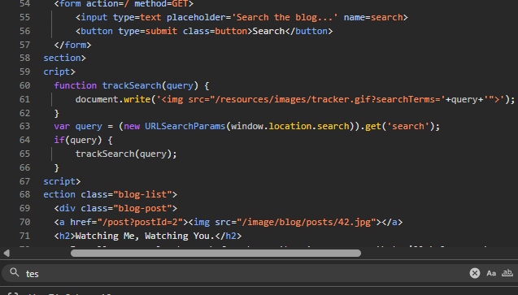
Figure 2

Summary steps:
1Searching
- URL parameter payload
- Javascript read the data of the URL payload and send it to the Sink (ducument.write) that performs or execute the malicious code and later on pops up the alert function as shown in figure 1 above
NOTE:
It is after execution of the malicious script that the user request is encoded hence the cause of DOM-Based Xss.

